

Student Name : Sagithya.T

Register No : 312220334

Department : IIIrd B.com (Computer Application )

College : Jeppiaar College of Arts and Science



**"Analyzing Employee Attrition through Job Satisfaction Feedback" using Excel**



1.Problem Statement

2.Project Overview

3.End Users

4.Our Solution and Proposition



5.Dataset Description

6.Modelling Approach

3

/

21/202

4

**A**

**nnu**

**al**

**R**

**e**

**v**

**i**

**e**

**w**



8.

Conclusion

7.Results and Discussion

# PROBLEM STATEMENT

To Analyse the Attrition i.e., Employee turnover by examining the Job satisfaction level by reviewing the feedback for job .



# PROJECT OVERVIEW

This project aims to examine employee attrition by •. analyzing job satisfaction levels through feedback. The goal is to identify patterns in turnover, understand the factors influencing job satisfaction. The findings will assist in developing strategies to improve job satisfaction, reduce turnover rates, and promote a more stable, motivated workforce.



***WHO ARE THE END USERS?***

## MANAGING DIRECTOR

ØHuman Resources (HR) Teams

ØManagement & Executives

ØTeam Leaders & Supervisors

ØData analyster

## ***OUR SOLUTION AND ITS VALUE PROPOSITION***

**Conditonal Formatting** - To Highlight the Blanks cells and change the colour of the cell .

**Sort & Filter** - Remove the Blank Missing Values. **Pivot Table** - Summary of Employee Turnover from the Company through job satisfaction. **Formulas** - IFS (To get the Feedback for Job) **Graphs**- (Bar Chart & Pie Chart) - FINAL REPORT on Employee details .

# Dataset Description

**Employee Attrition Dataset** - Kaggle.com

**Variables** : 35 Features

**Age** = <int> Numerical Values

**Attrition** = <fct> Text Values (Yes/No)

**Gender** = <fct> Text Values (Male/Female)

**Job Level** = <int> Numerical Values

**Job Satisfaction** = <int> Numerical Values

**Feedback for Job** = <fct> Text Values

**Performance rating** = <int> Numerical Values

**Total Working Years** = <int> Numerical Values

**Overtime** = <fct> Text Values (Yes/No)

## ***THE "WOW" IN OUR SOLUTION***

New Formula Used : IFS

To Find out the Feedback for Job by

3

/

21/202

4

**A**

**nnu**

**al**

**R**

**e**

**v**

**i**

**e**

**w**



Analysing the Job Satisfaction Level .

# MODELLING

1. Dataset Collection - Employee Attrition Dataset
2. Dataset Preparation - Clearing Blanks, Filtering and Removing Blank data in the Dataset.
3. Using IFS formula to attain the Feedback for Job through Job Satisfaction Level (1,2,3,4) (Satisfied & Dissatisfied)
4. Insert Pivot Table to Summarize the Dataset on Employee Attrition based on Gender, Job Satisfaction Level, Attrition (Yes/No) and Feedback for Job.
5. Data Visualization using pivit table and Pie Chart to represent the turnover by gender and satisfaction level.
6. Final Report

## **RESULTS**

***PIE CHART VISUALIZATION***

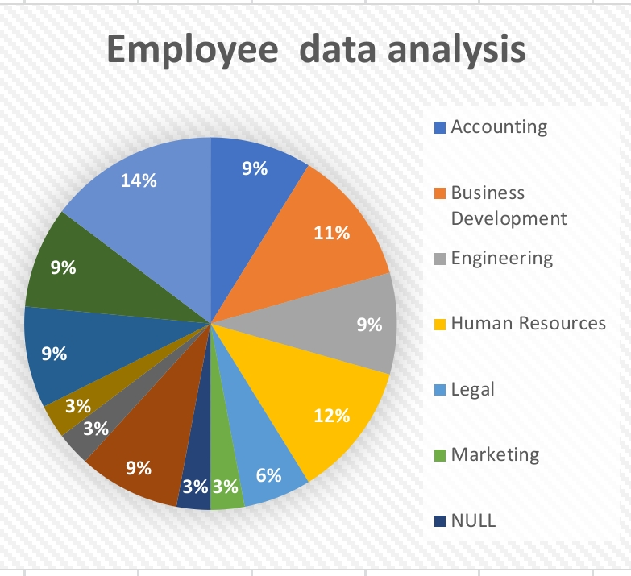

# Conclusion

In conclusion, this project highlights the important of employees satisfaction and company or firm

Some industries feedback and satisfaction and dissatisfaction level analysing this pivot table

And this one is very important

Of employees and HR.